Pet’s Name:_________________________ Date In: __________

Owner’s Name: _________________________ Date Out:__________

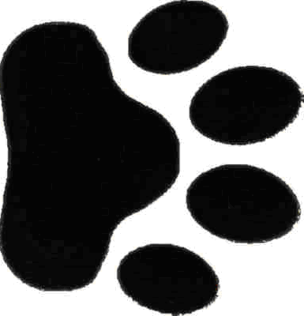

Personal Belongings:____________________________________________
________________________________________________________
Food: □Science Diet
Instructions: _______ cups _____ times daily in AM / PM.
□Own Food: _______________________
Instructions: _______ cups _____ times daily in AM / PM.

Kennel Staff Notes: _____________________________________________________

________________________________________________________

________________________________________________________

________________________________________________________

Adams Pet Hospital is not responsible for any lost, damaged or soiled personal items such as beds, blankets and toys belonging to my pet.

Signature: _______________________________

